**Biosand Filter Guideline**

# Outline

**Water Quality Assessment**

* Surface vs. groundwater
* Indicator organisms (E. coli)
* Turbidity
* Daily and seasonal variability

**Community Engagement**

* Education plan
* Community contribution
* Cultural/economic considerations

**Manufacturing and Distribution**

* Purchase from local supplier (fabricated in US)
* Purchase from local supplier (fabricated at in-country factory)
* On-site fabrication by local supplier/NGO
* On-site fabrication by EWB chapter
* On-site fabrication by community/local technicians

Filter body

Media

Discharge apparatus

Lid and Diffuser

**Biosand Filter**

* Construction
* Operation
* Maintenance

**Monitoring and Evaluation**

* Filter performance
* Operation and maintenance (community knowledge)
* Health benefits

# Introduction

The purpose of this document is to provide guidance for EWB-USA chapters who are considering using biosand filters (BSFs) as a household water treatment method for improving water quality. Specific topics for this guidance sheet include:

1. Source water assessment
   1. Surface vs. groundwater
   2. Indicator organisms (E. coli)
   3. Turbidity
   4. Daily and seasonal variability
2. Biosand filter technology
   1. Basic components
      1. Filter body
      2. Media
      3. Diffuser plate
      4. Discharge apparatus
   2. Filter construction
   3. Operation
   4. Maintenance
3. Community engagement
   1. Education plan
   2. Community contribution
   3. Cultural/economic considerations
4. Manufacturing and Distribution
5. Monitoring and evaluation
   1. Focal points for monitoring programs
   2. Filter performance
   3. Operation and maintenance (community knowledge)
   4. Health benefits

Specific details regarding biosand filter technology are available through numerous resources provided by the Centre for Affordable Water and Sanitation Technology (CAWST). Table 1 provides links to several documents that chapters should find useful during the planning and implementation phases of any biosand filter project. CAWST also provides training workshops (http://www.cawst.org/en/what-we-do/training-programs/training-schedule) in North America and around the world that can provide chapters with invaluable hands-on experience in constructing biosand filters as well as foundational knowledge on the technology and its capabilities in the developing world. Considerable resources (time and financial) are required to attend one of these workshops, but it can potentially save more than enough time and expense to justify the initial investment.

Table 1. Resources for biosand filters and other household water treatment technologies

|  |  |
| --- | --- |
| **Document Title** | **Link** |
| Biosand Filter Fact Sheet (Detailed) | http://resources.cawst.org/asset/biosand-filter-fact-sheet-detailed_en |
| Household Water Treatment and Safe Storage Manual | http://resources.cawst.org/package/household-water-treatment-and-safe-storage-manual_en |
| Introduction to Project Planning for Household Water Treatment | http://resources.cawst.org/package/project-planning-household-water-treatment-manual_en |
| Biosand Filter Construction Manual | http://resources.cawst.org/package/biosand-filter-construction-manual_en |
| Biosand Filter Sand Grain Size Analysis Instructions - | http://resources.cawst.org/asset/biosand-filter-sand-grain-size-analysis-instructions_en |
| Monitoring Biosand Filter Projects Manual | http://resources.cawst.org/package/monitoring-biosand-filter-projects-manual_en |
| Sandstorm: A biosand filter for small enterprises; Smith | http://wedc.lboro.ac.uk/knowledge/conference_papers.html |
| Rational Design of Bio Sand Filters; M. Kubare | www.iwaponline.com_jws_059_0001_0590001.pdf |

In addition to understanding all of the technical details required to construct, install, and maintain biosand filters, chapters should also be aware of how biosand filters fit into the overall EWB-USA program model for community partnerships on water resources projects. EWB-USA programs require a minimum of a five-year commitment to the partnership by the EWB-USA chapter and the community. Household water filtration (with biosand filters or any other household water treatment technology) is typically one project within a broader water resources program that may also include source development, storage, and/or distribution. Depending on the size of the community, the number of filters needed, and the manufacturing and distribution model that is developed by the chapter and the community, it may require five years for the successful implementation of a biosand filter project. The implementation process is flexible and can be scaled or adjusted to meet the needs of the community. Links to detailed descriptions of biosand filter projects that have been completed by EWB-USA chapters are provided in Table 2.

The timeline for a typical biosand filter project is provided in Figure 1. It should be noted, however, that every project is different and the specific details of each community/chapter partnership should determine the pace at which progress is made. There is a delicate balance between enthusiasm for progress within the community and ensuring that the necessary knowledge base and financial capacity of the community have been developed. Moving too slowly may result in a loss of interest, while moving too quickly may result in poorly constructed filters that nobody knows how to maintain.

Table 2. Peer-reviewed research articles* on project implementation of biosand filters by EWB-USA chapters

|  |  |
| --- | --- |
| **Document Title** | **Link** |
| Clean Water for La Ceiba El Salvador - Household Biosand Filters | http://library.queensu.ca/ojs/index.php/ijsle/article/view/5259 |
| Point-Of-Use Drinking Water Treatment in the Developing World: Community Acceptance, Project Monitoring and Revision | http://library.queensu.ca/ojs/index.php/ijsle/issue/view/383 |
| Addressing Water Quality Issues in Rural Cameroon with Household Biosand Filters | http://library.queensu.ca/ojs/index.php/ijsle/article/view/3208 |

* Articles appear in the International Journal for Service Learning in Engineering

Year 5

Year 4

Year 3

Year 2

Year 1

Establish partnership

Preliminary assessment

Develop goals and objectives

Detailed assessment

Demonstration Project   
(introduce BSF technology)

Education and training

Develop manufacturing and distribution model

Pilot implementation   
(using developed model)

Assessment of pilot implementation

Large scale production and distribution

Monitoring and evaluation

Education and training for maintenance and troubleshooting

Figure 1. Possible timeline for implementing a biosand filter project as part of an EWB-USA program

# How do Biosand Filters Work?

Biosand filters remove contaminants from water in a manner that is very similar to a traditional community scale slow sand filter. Mechanical removal of parasites (assumed to be 100%) and bacteria (~50% – 60%) is provided by the media. A biologically active zone (*schmutzedecke*) also forms within the top several inches of media that provides an additional mechanism for predation of contaminants by microorganisms. Under ideal circumstances, biosand filters have been shown to effectively remove more than 95% of the bacteria contained in the source water.

The primary difference between community scale slow sand filters and household biosand filters is that biosand filters are designed specifically for intermittent use. A standing water level of 2 inches must be maintained in the filter at all times to ensure that the biological layer does not dry out. Limiting the standing water level to 2 inches also ensures that the bio-layer can receive sufficient oxygen through diffusion from the surface. Community scale slow sand filters typically require standing water depths on the order of 3 ft. in order to avoid disturbing the bio-layer. Because of the relatively high standing water level in community scale filters, the filter must be operated continually in order to keep the bio-layer supplied with oxygen.

The volume of water that can be effectively treated by a household biosand filter on a daily basis is limited. The filter should be used on a daily basis in order to ensure that micro-organisms residing in the schmutzedecke receive sufficient oxygen and other nutrients. CAWST recommends a maximum of 48 hours between filter operations. It is also important to provide a “pause-period” between water batches of at least one hour. This will ensure some residence time in the filter and allow the treatment processes to complete before the water is flushed out by the next batch. Basic operating criteria for Version 10 of the CAWST biosand filter are as follows:

**Maximum Flow Rate** = 0.4 liters/minute

**Batch Volume** = 12 – 18 liters

**Maximum daily treatment volume** = 24 – 72 liters

Chapters should consider very carefully all of the implications associated with the limited treatment volume of 24 to 72 liters per filter per day. This volume should be sufficient to meet the basic drinking water needs for a family up to 10 people, but it will not necessarily meet all of the water needs for a household (cooking, cleaning, bathing, etc.). CAWST shall not be the only resource used to evaluate the capability of this evolving technology to provide a treatment unit that will provide an adequate supply of safe water to each household.

The maximum flow rate of 0.4 liters per minute occurs when the filter is initially loaded and the difference between the standing water level in the filter basin and the filter discharge point is maximum. As water passes through the filter and the elevation difference between the water level in the basin and the discharge point decreases, the flow rate will also decrease. Processing a single batch may require up to two hours. The filter’s flow rate will also decrease as turbidity in the source water begins to clog the pore spaces in the filter media. If the filter isn’t cleaned using the appropriate “swirl and dump” method, the flow will eventually stop altogether. It is very important to include an education plan for operation and maintenance of the filters as part of the overall implementation strategy.

# Biosand Filters: One Step in a Multi-Step Process

Ensuring a safe water supply at the community scale typically requires more than treating water with a filtration device. Source protection, sedimentation, disinfection, and safe water storage are also critical elements that should be addressed by any comprehensive plan that is developed by an EWB chapter and a partner community.

The municipal water supply for New York City is provided by surface water runoff from large watersheds in the Catskill Mountains. Because of the extensive measures put in place to protect these watersheds, the U.S. EPA has granted the city a “10-Year Filtration Avoidance Determination” that began in 2007. This means that the water quality is so high at the source that filtration is not required. Nonetheless, the water is still disinfected with chlorine and UV radiation before it is distributed to city residents.

Numerous field studies on the effectiveness of biosand filters indicate that they are capable of removing, on average, roughly 90% of the bacteria that is present in source water. Depending on the age of the filter, the quality of the media, and the total volume of water passed through the filter on a daily basis, removal rates have been shown to vary between 40% and 95% under field conditions. As a result, disinfection remains a critical step before the water may be considered safe to drink. There is typically strong resistance to chlorination of drinking water in developing communities, so chapters are encouraged to think creatively about how the need for disinfection will be introduced and what the long-term strategy will be for reinforcing this requirement throughout the life of the project. Safe water storage is also a critical element of the process that may require sustained effort in the form of educational programing.

Source Protection

Sedimentation

Filtration

Disinfection

Safe Water Storage

Household or Community Scale Water Treatment

Figure 2: Multi-step approach for ensuring a safe water supply.

# Water Quality Assessment

Water quality assessment is a critical step in developing effective solutions for a community’s water needs. The items listed below focus on issues that are significant for biosand filters. Chapters should also perform a comprehensive water quality assessment as outlined in the EWB-USA Water Testing Guidance Sheet available on the Project Resources section of the myEWBUSA website.

1. **Surface vs. groundwater**

Biosand filters are typically considered effective for removing biological contaminants (e.g. bacteria, protozoa, and helminthes) and turbidity from surface waters. Most groundwater sources are expected to be free from biological contaminants, although this may not be true for shallow wells or springs that are directly influenced by contaminated surface water. Biosand filters are not considered effective for removal of dissolved chemicals, but there has been research into modified versions of the biosand filter for arsenic removal.

1. **Indicator organisms (E. coli)**

The objective of the most commonly applied field test for biological contamination is to identify E. coli bacteria. E. Coli is a thermotolerant fecal coliform that is present in the feces of animals, and its presence in a source water suggests a high probability that other undesirables, such as protozoa and helminthes, are also present. Some test methods seek only to identify the presence/absence of E. Coli, while other test methods will quantify the number of E. Coli bacteria present in a water sample (reported in terms of colony forming units (CFU) per 100 ml of water).

1. **Turbidity**

The recommended turbidity limit for raw water going into a biosand filter is 50 NTU. Higher levels of turbidity will result in frequent clogging of the filter. Frequent clogging will require frequent cleaning, which will inhibit the formation of the biolayer. Source waters with turbidity levels greater than 50 NTU should be allowed to settle until the desired turbidity level can be achieved. Depending on the source of the turbidity, this may require the use of a coagulant.

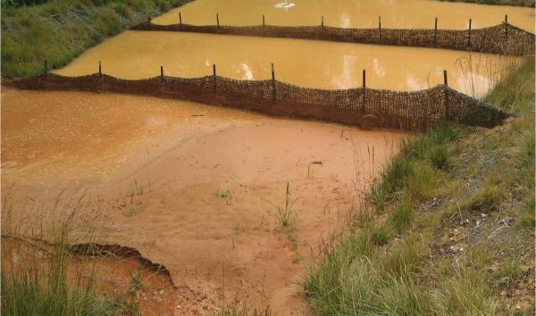

Figure 3: Example of high turbidity source water that is NOT appropriate for biosand filters without significant pre-treatment (image obtained from <http://ntuinc.com/>).

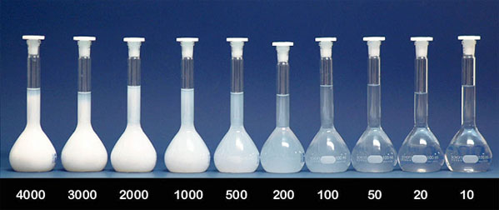

Figure 4: Photo illustration of turbidity levels in NTU. CAWST recommends limiting the turbidity level to 50 NTU for treatment with a biosand filter. (image obtained from <http://www.optek.com>/  
Turbidity_MeasurementUnits.asp)

1. **Daily and seasonal variability**

The level of E. coli contamination and turbidity in a water source may change on a daily or seasonal basis. Land use patterns and rainfall characteristics are common causes for this variation. It is extremely important for the chapter and the community to clearly identify the entire range of source water turbidity levels as they fluctuate in response to rainfall events or other seasonal variations. While turbidity does pose some challenges to biosand filters, it should be noted that one of the main complaints with community scale slow sand filters is that they clog during spikes in turbidity levels. With proper education and experience, biosand filter users can use their own judgment to determine whether or not the water is suitable for the filter. Users will also typically have a good understanding of how the turbidity levels of their water source will respond to rainfall events. They can use this knowledge to schedule water collection activities and avoid overloading the filter with turbidity.

# Biosand Filter Technology

1. **Basic components**
2. Filter body – Biosand filter bodies are typically made from concrete or plastic. The quality of the filtered water is not likely to be effected by the filter body material, but there are a number of factors to consider when making this decision (Table 3).

Table 3. Advantages and disadvantages for concrete and plastic filter bodies.

| **Filter body material** | **Advantages** | **Disadvantages** |
| --- | --- | --- |
| Concrete | * Very durable if constructed using correct concrete mix design (CAWST estimates 30 years and has verified concrete filters working 10 years after construction) * Unit cost for materials is typically low (<$15) * All materials required for producing filter bodies are typically available locally * Easily repaired using local resources if cracks or leaks develop * Heavy weight ensures that filter is unlikely to be moved or repurposed * The discharge apparatus can be fully encased in the front wall of the filter during casting. This prevents damage to the outlet tube and ensures that the final height at the discharge point will remain constant. | * Extremely heavy and difficult to move * Requires steel forms. Filters must cure in the forms for ~24 hours, which limits the rate of filter production. * Improper handling during transport may lead to cracks or broken filters |
| Plastic | * Lightweight and easy to move. | * The type of plastic used may introduce durability concerns * High quality plastic containers (HDPE) are expensive * Cracks in plastic are not easily repaired. If cracks form at the base of the filter it will drain and become unusable. * Light weight makes filters easy to move and plastic filter bodies are easily repurposed. * The discharge apparatus typically passes through the filter body at the bottom of the filter. This creates a weak point in the filter body where it is subjected to some of the highest stresses. There is also a tendency for the discharge apparatus to leak at the exit point. This may result in the filter draining entirely. |

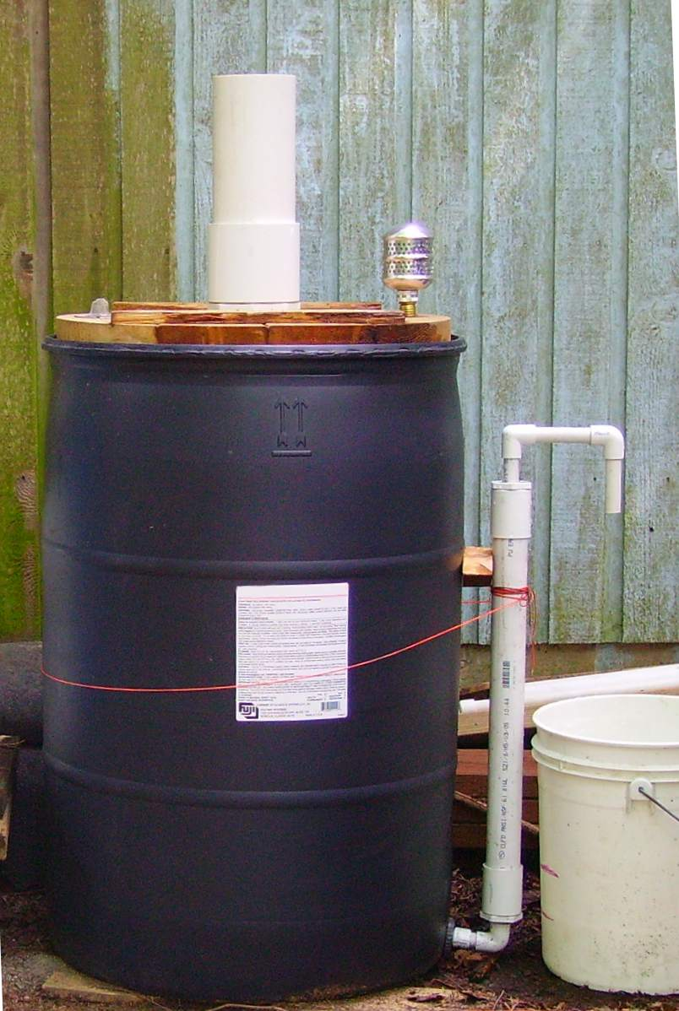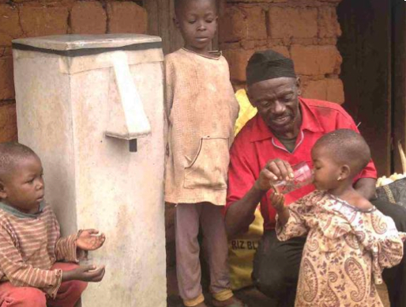

http://en.howtopedia.org/wiki/How_to_Filter_Water_with_a_Sand_Filter

http://akvopedia.org/wiki/Concrete_Biosand_Filter

(A) (B)

Figure 5. (A) Plastic filter body and (B) concrete filter body.

1. Media – the most important component of the biosand filter is the media. CAWST recommends the following as potential sources for media (ranked from most desirable to least desirable):
2. Crushed rock
3. Quarried sand (mined from a dry location)
4. River sand (extracted from high on the river banks)
5. River sand (extracted from river bottom – Warning!!! This may contain pathogens and/or other organic materials that will adversely affect the performance of the biosand filter)

Crushed rock and quarried sand are usually obtained from large, industrial facilities. Transportation costs are often the limiting factor when deciding whether or not to obtain the filter media locally or to import it from an off-site location.

The particle size and distribution of the media is what ultimately determines the flow rate and pathogen removal capabilities of the filter. If the media is too large, the flow rate in the filter will be too fast and pathogen removal will be limited. If the media is too small, the flow rate will be too slow and the filter will not provide an adequate volume of water to meet the needs of the user. The following guidelines are provided by CAWST for evaluating the suitability of a proposed media source:

* Only clean and dry particles that pass through a #24 screen (<0.7 mm or 0.03 in) should be evaluated and used as filter media.
* The recommended effective size (d10) is between 0.15 mm and 0.20 mm
* The recommended uniformity coefficient (d60/d10) is between 1.5 and 2.5
* The percentage of the media smaller than the #150 mesh size (0.1 mm) should be less than 4%.
* Effective size and uniformity coefficient should be based on a particle size distribution curve obtained using #24, #40, #60, #80, and #150 mesh screens. CAWST provides detailed instructions for obtaining a particle size distribution curve in the field using a volumetric basis instead of weight. This is considered a field method for rapid assessment and is not typically used in engineering practice.

1. Diffuser plate – A diffuser plate is required to absorb energy when water is poured into the receiving basin of the filter. An effective diffuser plate will ensure that the top of the sand layer is not disturbed when a bucket containing the entire treatment volume is poured into the filter rapidly. Diffuser plates can be constructed from plastic or metal sheeting. CAWST recommendations for diffuser plate characteristics are as follows:

* Holes in the diffuser plate should be 3 mm in diameter and spaced evenly in a grid at 2.5 cm (1 in)
* The diffuser should fit tightly in the filter and there should be no gaps between the filter wall and diffuser plate
* The diffuser should be easy to remove for cleaning

1. Discharge apparatus – The discharge apparatus conveys filtered water from the bottom of the filter (after it passes through the media) into the safe water storage container. Key features of the discharge apparatus include:

* The high point elevation of the discharge apparatus will control the standing water level in the filter. A standing water level of 2 in (5 cm) should be maintained in the filter at all times.
* An extension tube should not be used on the end of the discharge apparatus. This may result in a siphoning action that drains the water level in the filter below the recommended standing water level.
* For plastic filters where the discharge apparatus exits at the bottom of the filter, great care should be taken to ensure that leaks do not develop around the through hole. In addition to the general annoyance of puddling water around the base of the filter, severe leaks may result in the filter draining completely. In order to restart a dry filter, all of the media must be removed and replaced.

# Manufacturing and Distribution Options for EWB-USA Projects

A key element of all EWB-USA projects is community contribution and developing effective strategies for community engagement. If household water treatment using biosand filters has been identified as the most feasible solution for addressing the drinking water treatment needs of the community, the next step is for the EWB-USA chapter and the community to develop a manufacturing and distribution model. Several different manufacturing and distribution models have been identified for consideration by EWB-USA chapters and their community partners. There are no steadfast rules for determining which model is the best or which model is the most appropriate for a specific community.

Choosing a model, or developing a new one, should be a collaborative process through which the strengths and capabilities of both the community and the EWB-USA chapter are identified. Limitations and resource constraints should also be acknowledged. It is also very likely that whatever model is agreed upon in the beginning will need to be evaluated and adjusted as the project gains (or loses) momentum. The ultimate goal is to introduce this technology in such a way that those utilizing it have a thorough understanding of the following:

* how it works
* why it is important
* how to maintain it
* where to go for support if they encounter problems that they cannot address on their own.

At a minimum, the manufacturing and distribution model should rely on locally available resources. During the initial stages of a project, when the chapter is introducing biosand filters as a new technology, it may be appropriate for the chapter to purchase pre-fabricated filters (Figure 4) in the capital city and use them as a demonstration tool to raise awareness and gage community interest. These filters can also be used to determine if the local water sources are amenable to treatment with biosand filters.

 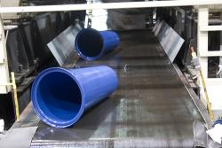

Figure 6: Prefabricated plastic filters manufactured in the U.S.

Chapters should also investigate if there are other NGOs involved in biosand filter production around the country. A number of large scale filter manufacturing facilities (Figure 5) have been established in capital and provincial cities around the globe. If the filter bodies are made from concrete, transporting the filter bodies long distances is often prohibitive. These NGOs may still be able to provide high quality media for the filters that may not be available closer to the community.

 

Figure 7: In-country filter manufacturing facility.

Some NGOs also have experience manufacturing a large number of concrete-body filters on-site within a specific community (Figure 6). While the cost associated with this model may be higher than having community members build their own filters, the time required will usually be much less and the resulting quality should be higher. The EWB-USA chapter can still play a critical role in monitoring the quality of the filters produced by the NGO and ensuring that they are installed correctly. The chapter may also take on the role of facilitating training for community members on filter maintenance and troubleshooting. Another potential advantage of this model is that community members will have an in-country contact for support if they ever have trouble with their filters. If this model is chosen, make sure that the NGO is credible and is willing to support the community while the technology is being established. The EWB-USA chapter should also visit other communities where the NGO has previously implemented projects.

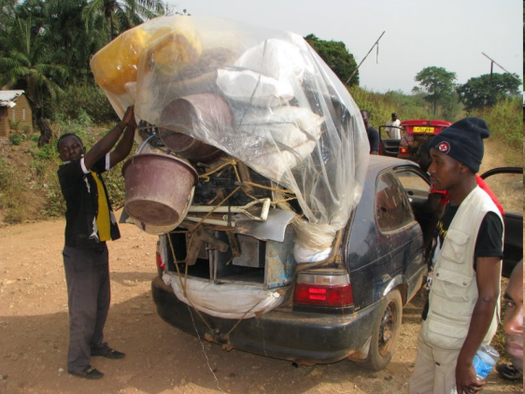 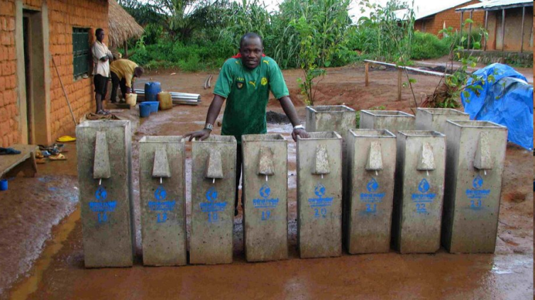

Figure 8: On-site fabrication by in-country NGO.

The EWB chapter may also take an active role in constructing filters within the community (Figure 7). It is important to spread the manufacturing out over an appropriate time period. This will ensure that the filters meet the desired level of quality and that the community has time to evaluate and build support for expanding the project. Even though the chapter may be taking the lead role in manufacturing the filters in the community, it is also important that the community is involved in the process and fully supports the project.

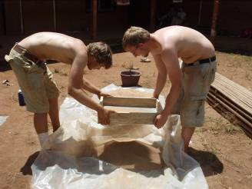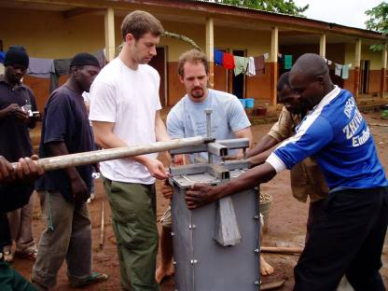

Figure 9: EWB-USA chapter builds filters in community with local support.

A final model for manufacturing and distribution involves on-site fabrication by the community members themselves (Figure 8). This is an ideal model, and many chapters have organized their filter programs around the idea that the ultimate goal is to empower the community to take action using their own skills and resources.

Designing and executing a training program for community-based filter construction is no small challenge. In addition to the requisite knowledge transfer and technical training that must occur, there are also a number of socio-cultural factors that must be considered before pursuing this strategy. If a group of filter technicians are going to be trained, who will be responsible for paying them for their work? If the EWB-USA chapter subsidizes this type of skilled labor for filter construction, this may create resentment amongst some community members who do not benefit financially from the project.

Finally, some chapters have reported serious issues with quality control for filters constructed by the community without EWB-USA oversight and support. Concrete quality has a tendency to drift when the proportions of water, sand, aggregate and cement are not tightly controlled. This is true in all countries around the world. Media preparation can also become incredibly tedious, and if proper procedures are not followed the filters will not perform as desired. Correcting these errors after the mistakes have been made is incredibly difficult. From a cultural perspective, it may be completely inappropriate to even identify deficiencies in a community member’s work. Establishing the criteria for what is acceptable and not acceptable should be a major priority before manufacturing is turned over to any community-based group.

If a chapter does employ a community-based manufacturing and distribution model, frequent visits by the chapter are strongly encouraged. At the very early stages, two months may be too long between monitoring and evaluation trips. As the community gains experience and the value of properly constructed filters is recognized, the length of time between visits by the chapter may naturally increase.

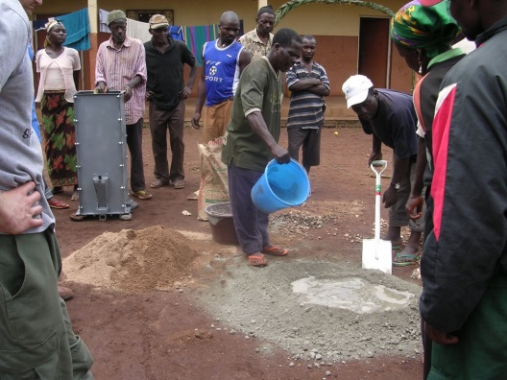 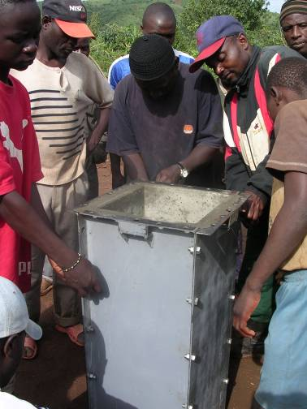 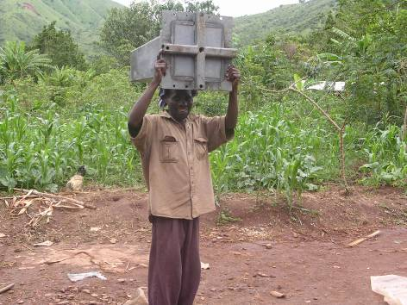

Figure 10: On-site fabrication by community members.

# Monitoring and Evaluation

Monitoring and evaluation is an important component of any development project. For biosand filters in particular, it is important to consider how the implementation will be assessed from the very beginning and how the feedback obtained will be used to direct future actions. Semi-annual visits by the chapter may not be sufficient to keep the project on course, and the NGO may be required to take an active role in monitoring and evaluation from the very beginning. Early phases of project monitoring will likely focus on ensuring quality control during the manufacturing and installation of the filters. Once the filters are constructed, the emphasis will shift towards monitoring and the performance of the filters as well as the knowledge transfer within the community. Finally, the chapter can move into a final evaluation phase to determine if broader goals relating to long-term sustainability have been achieved.

EWB-USA has developed extensive guidelines for Project Monitoring Evaluation and Learning (PMEL). Chapters are required to work within the existing EWB-USA framework for all monitoring and evaluation activities. The remainder of this section is intended to provide specific guidance for biosand filters and is not intended to supersede EWB-USA PMEL guidelines.

There are seven primary focal points for monitoring and evaluation of household water treatment projects using biosand filters:

1. Is the water volume produced adequate to meet household needs for:
   * 1. Drinking water
     2. Cooking
     3. Washing dishes
     4. Hand washing and personal hygiene
   1. How many filters are still in use?
   2. Filter performance – Does the filter remove the contaminants that it was intended to under field conditions?
   3. Does the family practice disinfection of filtered water and other safe water storage procedures?
   4. User knowledge – Are users of the technology sufficiently empowered and/or motivated to:
      1. Properly maintain their filter
      2. Obtain assistance from a trained technician in the community if a problem arises
      3. Obtain replacement parts or perform repairs if something breaks
   5. User enthusiasm – Does the technology meet the needs of the user? Are there any perceived benefits to using household water treatment?
   6. Health benefits – Are there measurable improvements in health outcomes for families using household water treatment?

## Filter Performance

The following data should be collected and archived for each filter:

At installation:

1. Location
2. Owners/operators
3. Who manufactured the filter?
4. Who installed the filter?
5. Standing water level when the filter is in its pause position (no water flowing through the filter).
6. Flow rate of water coming out of the filter at maximum head (immediately after a full charge of water has been added to the reservoir).
7. Diffuser plate present?
8. Suitable lid present?
9. Is a safe storage container present?

At six month intervals:

1. Standing water level when the filter is in its pause position (no water flowing through the filter).
2. Flow rate of water coming out of the filter at maximum head (immediately after a full charge of water has been added to the reservoir).
3. Diffuser plate present and clean?
4. Suitable lid present?
5. Are any cracks present or other evidence that the filter might be leaking?
6. Is a safe storage container present?
7. Is there any evidence that filtered water has been disinfected?

A subset of filters should be identified for more intensive water quality testing. This should include a microbial analysis of the raw water and filtered water in order to characterize the removal efficiency of the filter. Testing should also be performed for water samples obtained directly from the safe storage container. Results for raw water, filtered water, and stored water should be reported in terms of CFU of E. coli per 100 ml.

## User Knowledge

User training on operation and maintenance of biosand filters is a multi-phase process that needs to occur over an extended period of time. When a filter is first installed in a house, it is common for the filter technicians to demonstrate basic maintenance operations (like the swirl and dump method) and provide users with additional guidance on filter upkeep. Unfortunately, filter users may have a hard time assimilating the new knowledge without any prior experience of the problems they are being trained to remedy. If a filter clogs after one month of use (which is not uncommon) and the user is not prepared to deal with it effectively, the filter may sit idle until the chapter visits the community again.

The local partnering organization should be prepared to make frequent visits to the community in order to address problems as they arise. This should occur within the first few weeks after the first group of filters is implemented. Additional follow-up visits by the local partnering organization should occur between visits by the chapter to ensure that problems are identified and remedied as quickly as possible. It is important to stress to the partnering organization that their role during these visits is to troubleshoot identified problems and provide individual filter users with the knowledge they need to solve the problem. The partnering organization should not be expected to maintain the filters indefinitely.

Assessment of user knowledge by the chapter should occur at six month intervals. This assessment should focus on determining whether or not community members can:

1. Perform required routine maintenance
2. Fix something if it breaks
3. If the user cannot perform the required repair, do they have access to the resources required to obtain these services?
4. Expand the project and increase the number of people with access to the technology without relying on outside resources?

The time scales associated with these specific objectives varies significantly. Objective 1, perform required maintenance, should be achieved within the first two months following a filter implementation project. Because a chapter may not have another visit planned for six months to a year, the local partnering organization and/or community members will need to take the lead on follow-up training for new filter users. Objective 4, expanding the project using locally available knowledge and resources, may require several years of support and guidance by the EWB-USA chapter and the local partnering organization.

Some problems may need to be repaired by experienced technicians. Unfortunately, these problems may take years to manifest. A practical example of this occurred during an EWB-USA project involving biosand filters in a rural farming community in Cameroon, West Africa. Community members were initially trained to only clean their filters (swirl and dump) when the flow rate became too slow to meet the family’s water needs. This community did not have any type of centralized water distribution system at the time filters were implemented, so the total volume of water that they were using on a daily basis in the home was generally low. The family would collect one bucket of water in the morning and place it in the filter followed by one bucket in the evening. As long as the single bucket was passing through the filter in less than 12 hours, the flow rate was considered adequate.

After about three years of ongoing work in the community on other projects, some of the first filters that were installed became completely plugged. Most significantly, the swirl and dump cleaning method was not effective at restoring the flow rate. After further discussion with the users, it was determined that the filters had never been cleaned because the flow rate was never “too slow” (until it had stopped completely!). What ultimately happened was the suspended particulates in the raw water that are typically captured in the first two inches of media, and subsequently removed by the swirl and dump method, were allowed to migrate through the entire depth of the filter media and accumulate in the gravel layers at the bottom of the filter. The only solution was to remove and clean all of the filter media and gravel layers and then reinstall the filter. After further discussion with other filter users, additional filters that were on the verge of stopping were identified. While the problem wasn’t widespread, fixing it did require a level of expertise that the average community member did not have. It also required an adjustment in the education plan and the community was able to address the issue by cleaning their filters on a more regular basis.

## User Enthusiasm

Monitoring user enthusiasm is also critical to ensuring the long-term success and sustainability of a biosand filter project. This may be as simple as asking users if they like the filters to a more detailed qualitative assessment of user perceptions. Are users generally happy with the water quality produced by the filter? Does it represent a significant improvement to them even if they can’t perform a detailed microbial assessment of the raw and filtered water quality?

## Health Benefits

Long-term monitoring and evaluation of community health outcomes is a very involved process. Community health surveys should be designed and conducted by trained professionals with expertise in this field. Student chapters are encouraged to partner with faculty and student groups in colleges of public health or nursing at their respective institutions if direct measurement of public health outcomes is desired.

# Summary and Conclusions

The biosand filter is a point-of-use water treatment device that has the potential to significantly improve water quality at the household level in developing communities. Successful implementation of a biosand filter project within the context of a broader EWB-USA program depends on a number of factors that reach well beyond the technical details of a specific filter design. In general, chapters must consider how the following key components of a biosand filter project will be integrated and executed over the course of several years:

1. Manufacturing and distribution
2. User education and training
3. Technician education and training
4. Monitoring and evaluation

The advantage of the EWB-USA model is that chapters do have time to assess, organize, and collaborate with a community in order to develop an implementation plan that will lead to a sustainable project. If a chapter is also involved in a water distribution project that may take several years to design and implement, the biosand filter project can naturally evolve in parallel. As the chapter gains more experience working with a community and develops a strong working relationship that is built on trust and mutual respect, the likelihood for success increases significantly.

Problems tend to arise when the focus shifts away from community development and towards meeting targets for filter distribution or lowering unit cost. Unfortunately, EWB-USA chapters rarely have the necessary experience to know how well any given technology is going to perform under the circumstances they encounter. For biosand filter projects, identifying the “appropriate” manufacturing and distribution model is difficult. Knowing how much time and energy to spend on user education and training is also challenging, especially when the chapter feels pressure to produce tangible results and satisfy perceived demands from their donor base in the U.S. Developing the local knowledge that is necessary to sustain a biosand filter project is not a linear process and identifying a suitable model for achieving this goal may require several iterations. What should a chapter do when they return to a community and find that half of the filters that were implemented nine months ago are not working or simply not being used? Unfortunately, this happens more often than anyone would like to admit. Sometimes the problems are purely technical and the filters that were constructed had some inherent design flaw. That is usually an easy fix. More often, the problem lies in the area of education and training or a failure to reconcile the expectations of the community and the EWB-USA chapter with the realities of how difficult it is to address potable water challenges in resource-scarce environments. Hopefully, the knowledge and experience gained by EWB-USA chapters will lead to continual improvements with the success of biosand filter projects.